Validator Update Instructions for Rowe BC1200 $1 - $20

Kit Overview

The purpose of the kit is to replace the Rowe BA50 transport and stacker with a 120-volt Mars validator with a compact mask. The kit and these instructions pertain to a Rowe BC1200; this is a front-loading changer with two hoppers. There are two variations of the kit; one will process $1-$5 and the second $1-$20. This kit is designed for dollar bill changers that are not used to make change for a coin.

The installation information is intended for experienced personnel familiar with the operation of these components. All of the installation procedures must be reviewed and understood prior to installing the kit. The installation instructions are based upon a dollar bill changer that has not been modified from the original factory configuration. If the machine has been altered in any way, restore the machine to the original factory configuration prior to beginning the conversion.

Kit Components
The kit contains the following parts:
Module in black plastic box; labeled BC1200/1400/3500
Metal validator slide plate with wide opening – short style
Jumper with 15 position connector
Four of 11/32 keps nuts

Additional Required Items Not Included With Kit
Working Mars validator – Model AE2411/AE2451, VN2511, or AE2611
Dollar bills to test the validator and verify operation of the kit
Electrical tape

Tools Required
11/32”, ¼”, and 3/8” long handle nut drivers
Pliers

Installation Instructions
- Unplug the power cord from the wall and open the door of the changer.
- Remove the BA50 bill transport by unplugging the harness at the 15-position harness connector (3 x 5). A 12-inch harness will still be connected to the side of the BA50 transport.
- Connect the jumper supplied with the kit to the now open 15-position connector of the machines wiring harness.
- Remove the bill box(es) from the stacker assembly.
- Remove the stacker assembly by unscrewing the two ¼”screws at the top of the assembly. It may be necessary to hold the nuts under the assembly with a pair of pliers. [For changers with a dual stacker: remove the two ¼” screws that secure the stacker assembly base to the bill box bracket. The bill box bracket can remain in the changer] Disconnect the harness from the upper rear right hand side. Slide the stacker assembly forward out of the changer. Replace the upper two screws and nuts. The original stacker harness will not be connected to any component.
- Set the dip switches on the 120v Mars validator per the label on the kit Module.
- Unplug the 9-position harness at the Coin Acceptor Assembly. If the changer was not originally equipped with a Coin Acceptor Assembly on the front door, it will be necessary to look behind the hopper assembly for the harness. Figure 4 shows a changer with a factory installed Coin Acceptor Assembly.
- Insert the 9-position harness from the new Module into the open connector. This kit is not designed for use in a changer that accepts coins. If there is a coin acceptor on the front door the 9-position connector will remain open. If you need to accept coins, please contact us for a coin interface kit.
- Remove the right hopper from the changer for easy access to the power junction box.
- Unplug the 3-position power harness from the power junction box located on the upper area of the right side of the cabinet. Plug the 3 position male connector from the kit into the now open connector. Plug the machine harness into the 3 position female connector of the wiring harness from the Module. See figure 5.
- Mount the kit Module to the right hand wall of the changer using Velcro. See figure 5.
- Mount the validator onto the metal validator slide plate; the four 11-32 keps nuts are supplied with the validator. A twelve-inch factory harness may be connected to the validator when it is removed from the box. Unplug this harness, as it is not used with the kit. If the validator’s dipswitches have not been set, set them now. The label on the Module lists the various settings.
- Slide the validator plate assembly down the tracks that originally secured the BA50 transport. Attach the harness from the Module with the long black connector to the validator. Note the position of the two “keyed pins” when attaching the connector.
- If the machine was not factory fitted with a Coin Acceptor Assembly this step can be skipped. Remove either of the 2 wires from the coin return switch; red or black. Wrap the terminal in electrical tape.
- At this point, the BILL CHANGER CONTROL COMPUTER is reprogrammed. Plug the cord back into the wall outlet. After a 10 second warm up period the “walking blue dash” will appear on the BILL CHANGER CONTROL COMPUTER and begin scrolling back and forth.

The 3 most popularly used programs are described below. The programming assumes 4 quarters will be dispensed for each dollar value inserted. If you are dispensing dollar coins divide the number of coins to be dispensed by 4. The below instructions can be used as a basis for substituting your own values if needed. The values you are programming may seem odd, however the validator now controls the denominations accepted. The MC mode is recommended if you are dispensing the same value coin in both hoppers. The operation of the MC Mode is described on page 2-12 in the Rowe BC-1200/1400 Bill & Coin Changer Field Service Manual and Parts Catalog; fifth edition.

MC MODE - 4 COINS PER DOLLAR VALUE

- Slide the BILL CHANGER CONTROL COMPUTER forward so it is easy to view the blue display and access the programming buttons.
- Slide the mode switch upwards to the programming mode, the display will read TEMP COUNTERS.
- Depending upon the vintage of the BILL CHANGER CONTROL COMPUTER, the FUNCTION button may be labeled as FUNCTION or FUNCTION-ERROR RESET. These instructions refer to the button as FUNCTION.
- Press the FUNCTION button, the display will read PERM COUNTERS.
- Press the FUNCTION button, the display will read PROGRAMMING __ __ __ __. If a security code was entered earlier enter the code now.
- Press the FUNCTION button, the display will read MC PAYOUT. It must be set to ON. Use either of the COUNT SWITCHES BUTTONS to set this option to ON.
- Press the FUNCTION button, the display will read HOP VAL; the value of coins for the left hopper will be flashing. Press the VALUE button until the display reads T1.
- Press the HOPPER button; the display will advance to the right hopper. Press the VALUE button until the display reads T1.
- Press the FUNCTION button, the display will read ACCEPT 1; this is set to NO. The NO and YES options are toggled using the COUNT SWITCHES.
- Press the VALUE button, the display will read ACCEPT 2; this is set to NO.
- Press the VALUE button, the display will read ACCEPT 5; this is set to YES.
- Press the VALUE button, the display will read ACCEPT 10; this is set to NO.
- Press the VALUE button, the display will read ACCEPT 20; this is set to NO.
- Press the VALUE button, the display will read ACCEPT 25; this setting must be set to YES.
- Press the VALUE button, the display will read ACCEPT 25A; this setting is set to NO.
- Press the VALUE button, the display will read ACCEPT 50; this is set to YES.
- Press the FUNCTION button, the display will show 25 PAY ___ MC MC. Use the COUNT SWITCH BUTTONS to set the value to 4. Use the COUNT SWITCHES to change the value. This value determines the number of coins to be dispensed for a $1 bill; twice the amount of coins for a $2 bill.
- Press the VALUE button, the display will show 50 PAY ___ MC MC. Use the COUNT SWITCHES BUTTONS to set the value to 20. Use the COUNT SWITCHES to change the value. This value determines the number of coins to be dispensed for a $5 bill.
- At this point all of the programming changes needed for the kit have been made, slide the function button down to the NORMAL OPERATING MODE. The display will indicate Storing New Data.
- The walking blue dash will begin scrolling. The two green arrows on the validator will begin blinking.

NON MC MODE - 2 QUARTERS FROM EACH HOPPER FOR A $1 BILL & 10 QUARTERS FROM EACH HOPPER FOR A $5 BILL
- Slide the BILL CHANGER CONTROL COMPUTER forward so it is easy to view the blue display and access the programming buttons.
- Slide the mode switch upwards to the programming mode, the display will read TEMP COUNTERS.
- Depending upon the vintage of the BILL CHANGER CONTROL COMPUTER, the FUNCTION button may be labeled as FUNCTION or FUNCTION-ERROR RESET. These instructions refer to the button as FUNCTION.
- Press the FUNCTION button, the display will read PERM COUNTERS.
- Press the FUNCTION button, the display will read PROGRAMMING __ __ __ __. If a security code was entered earlier enter the code now.
- Press the FUNCTION button, the display will read MC PAYOUT. It must be set to OFF. Use either of the COUNT SWITCHES BUTTONS to set this option to OFF.
- Press the FUNCTION button, the display will read HOP VAL; the value of coins for the left hopper will be flashing. Press the VALUE button until the display reads T1.
- Press the HOPPER button; the display will advance to the right hopper. Press the VALUE button until the display reads T1.
- Press the FUNCTION button, the display will read ACCEPT 1; this is set to NO. The NO and YES options are toggled using the COUNT SWITCHES.
- Press the VALUE button, the display will read ACCEPT 2; this is set to NO.
- Press the VALUE button, the display will read ACCEPT 5; this is set to YES.
- Press the VALUE button, the display will read ACCEPT 10; this is set to NO.
- Press the VALUE button, the display will read ACCEPT 20; this is set to NO.
- Press the VALUE button, the display will read ACCEPT 25; this setting must be set to YES.
- Press the VALUE button, the display will read ACCEPT 25A; this setting is set to NO.
- Press the VALUE button, the display will read ACCEPT 50; this is set to YES.
- Press the FUNCTION button, the display will show 25 PAY ___ --- ___. Use the COUNT SWITCH BUTTONS to change the value for the left hopper to 2. Press the HOPPER button to advance to the right hopper value. Use the COUNT SWITCHES to set the value at 2. This value determines the number of coins to be dispensed for a $1 bill; twice the amount of coins for a $2 bill.
- Press the VALUE button, the display will show 50 PAY ___ --- ___. Use the COUNT SWITCHES BUTTONS to change the value for the left hopper to 10. Press the HOPPER button to advance to the right hopper value. Use the COUNT SWITCHES to change set the value to 10. This value determines the number of coins to be dispensed for a $5 bill.
- At this point all of the programming changes needed for the kit have been made, slide the function button down to the NORMAL OPERATING MODE. The display will indicate Storing New Data.
- The walking blue dash will begin scrolling. The two green arrows on the validator will begin blinking.

NON MC MODE - 3 QUARTERS AND 5 NICKELS FOR A $1 BILL & 19 QUARTERS AND 5 NICKELS FOR A $5 BILL

- Slide the BILL CHANGER CONTROL COMPUTER forward so it is easy to view the blue display and access the programming buttons.
- Slide the mode switch upwards to the programming mode, the display will read TEMP COUNTERS.
- Depending upon the vintage of the BILL CHANGER CONTROL COMPUTER, the FUNCTION button may be labeled as FUNCTION or FUNCTION-ERROR RESET. These instructions refer to the button as FUNCTION.
- Press the FUNCTION button, the display will read PERM COUNTERS.
- Press the FUNCTION button, the display will read PROGRAMMING __ __ __ __. If a security code was entered earlier enter the code now.
- Press the FUNCTION button, the display will read MC PAYOUT. It must be set to OFF. Use either of the COUNT SWITCHES BUTTONS to set this option to OFF.
- Press the FUNCTION button, the display will read HOP VAL; the value of coins for the left hopper will be flashing. Press the VALUE button until the display reads T1.
- Press the HOPPER button; the display will advance to the right hopper. Press the VALUE button until the display reads T1.
- Press the FUNCTION button, the display will read ACCEPT 1; this is set to NO. The NO and YES options are toggled using the COUNT SWITCHES.
- Press the VALUE button, the display will read ACCEPT 2; this is set to NO.
- Press the VALUE button, the display will read ACCEPT 5; this is set to YES.
- Press the VALUE button, the display will read ACCEPT 10; this is set to NO.
- Press the VALUE button, the display will read ACCEPT 20; this is set to NO.
- Press the VALUE button, the display will read ACCEPT 25; this setting must be set to YES.
- Press the VALUE button, the display will read ACCEPT 25A; this setting is set to NO.
- Press the VALUE button, the display will read ACCEPT 50; this is set to YES.
- Press the FUNCTION button, the display will show 25 PAY ___ --- ___. Use the COUNT SWITCH BUTTONS to set the value for the left hopper to 3 (quarters). Press the HOPPER button to advance to the right hopper value. Use the COUNT SWITCHES to change the value to 5 (nickels). This value determines the number of coins to be dispensed for a $1 bill; twice the amount of coins for a $2 bill.
- Press the VALUE button, the display will show 50 PAY ___ --- ___. Use the COUNT SWITCHES BUTTONS to change the value for the left hopper to 19 (quarters). Press the HOPPER button to advance to the right hopper value. Use the COUNT SWITCHES to set the value at 5 (nickels). This value determines the number of coins to be dispensed for a $5 bill.
- At this point all of the programming changes needed for the kit have been made, slide the function button down to the NORMAL OPERATING MODE. The display will indicate Storing New Data.
- The walking blue dash will begin scrolling. The two green arrows on the validator will begin blinking.

Insert several $1.00 dollar bills and then $5.00 dollar bills to confirm proper operation.

Revision 01102015

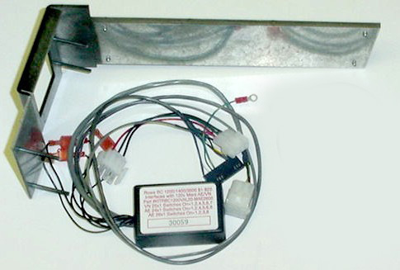
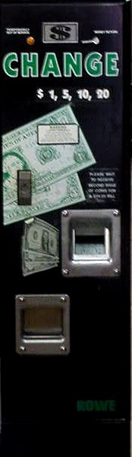
Rowe BC 1200
Figure 1
Figure 2
Figure 3
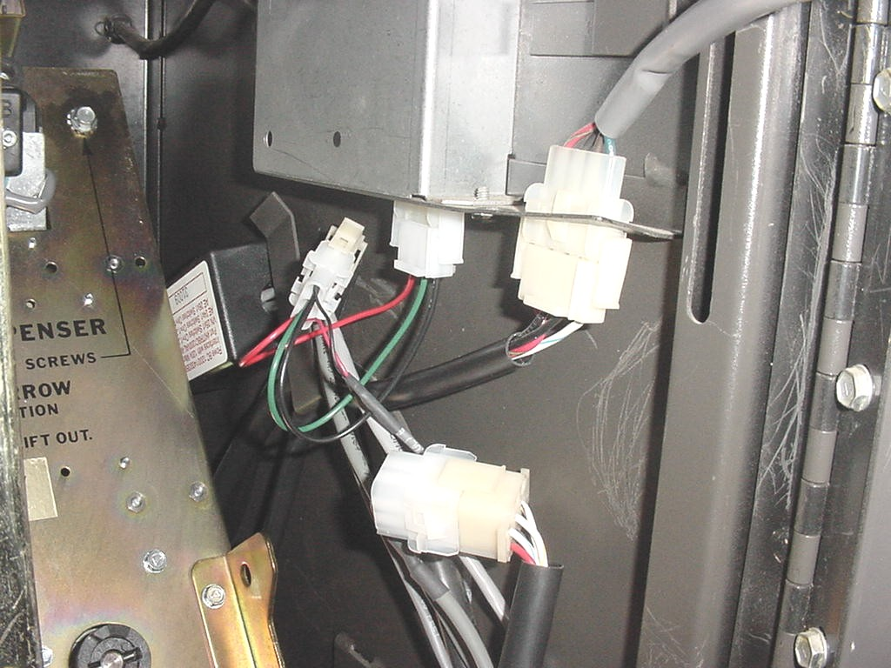
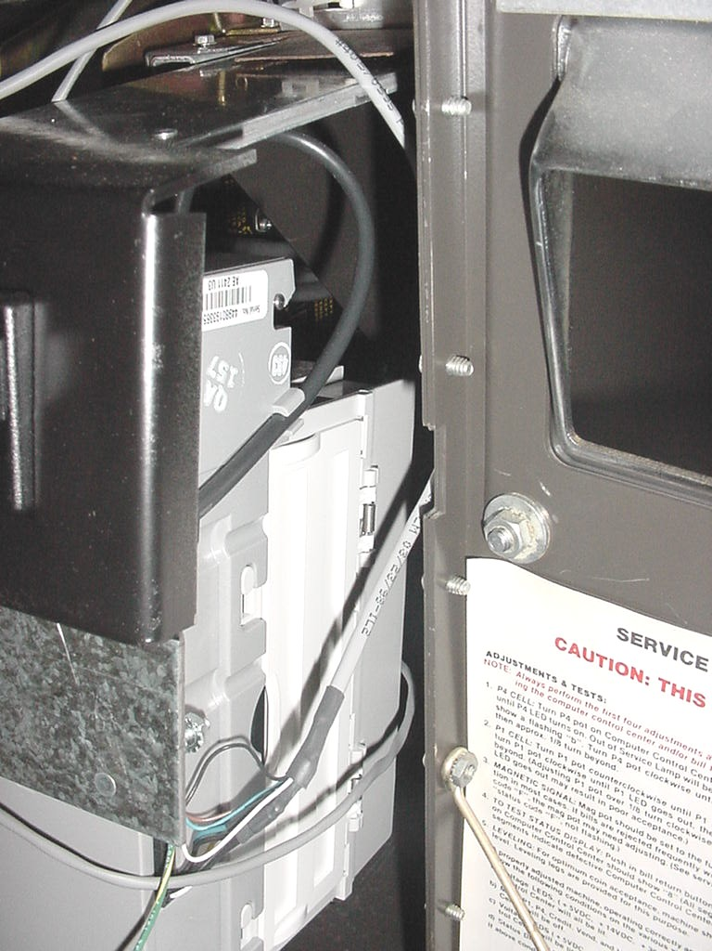
Figure 5

Figure 6

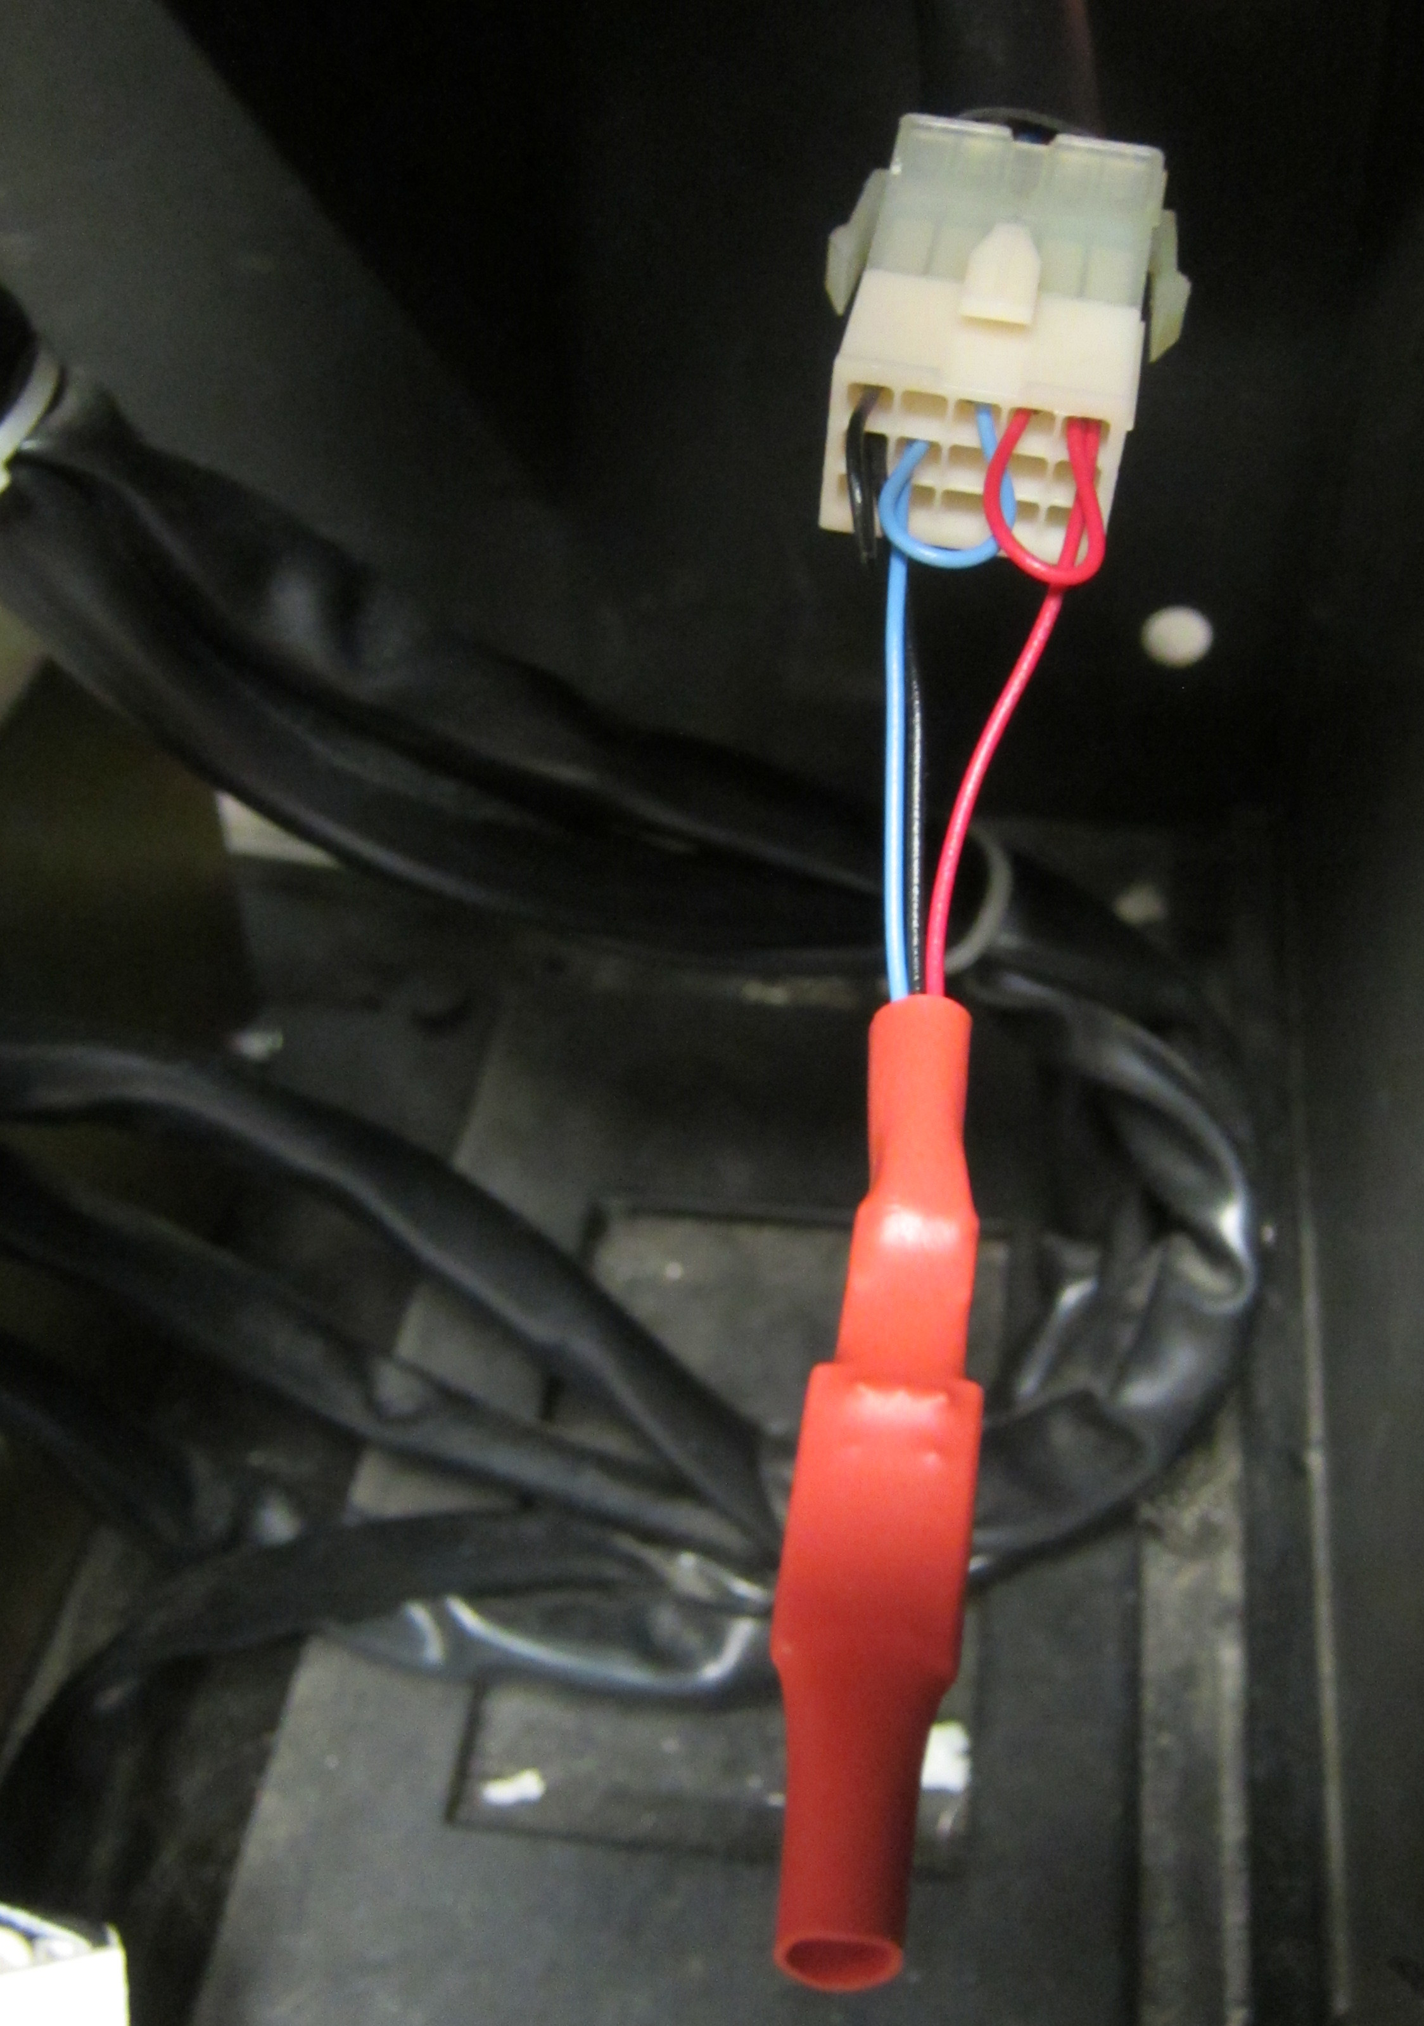
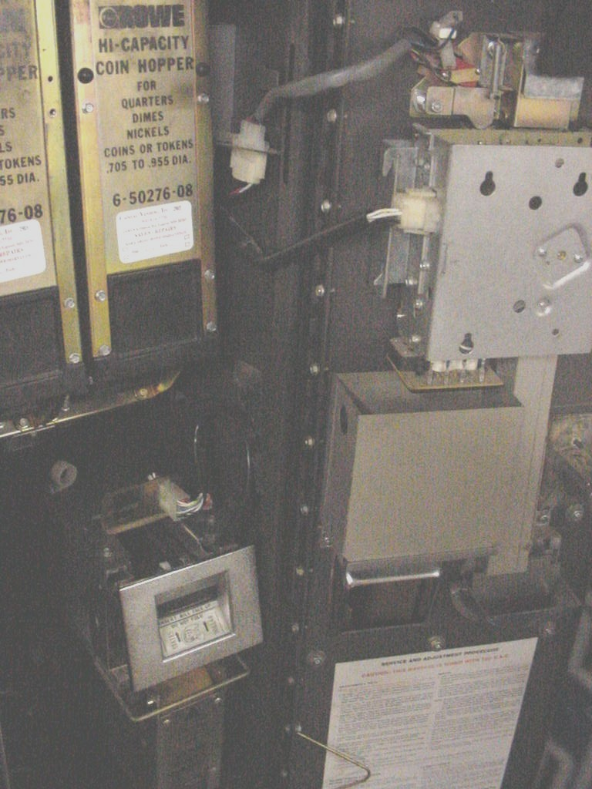

Figure 4

